MEGHNAD SAHA INSTITUTE OF TECHNOLOGY

*Techno Complex, Madurdaha,Beside NRI Complex, Post-Uchhepota, Kolkata 700 150*

LABORATORY NOTE BOOK

MAKAUT EVEN SEMESTER 2023



[BACHELOR OF COMPUTER APPLICATION]

[INTERNET TECHNOLOGY LAB (BCAC492)]

[RUPAK SARKAR]

ROLL NO: 31001221010 REGN. NO.: 213101001210001

STREAM: BCA SEMESTER: V (5TH)

YEAR: 3RD YearSESSION: 2021-2024



MAULANA ABUL KALAM AZAD UNIVERSITY OF TECHNOLOGY



MEGHNAD SAHA INSTITUTE OF TECHNOLOGY

*Techno Complex,. Madurdaha,Beside NRI Complex, Post-Uchhepota, Kolkata 700 150*

“LIST OF ASSIGNMENT/EXPERIMENT SUBMISSION DETAILS”

|  |  |  |  |  |  |
| --- | --- | --- | --- | --- | --- |
| **SL.**  **NO.** | **ASSIGNMENT / EXPERIMENT NAME** | **PLANNED DATE OF SUBMISSION** | **ACTUAL DATE OF SUBMISION** | **CHECKED BY** | **REMARKS (ANY DEVIATION REGARDING SUBMISSION DATES, CONTENT, FORMAT, ETC)** |
| 1. | Create a Table in HTML |  |  |  |  |
| 2. | Create a Nested List in HTML. |  |  |  |  |
| 3. | Create a Table using Pre tag. |  |  |  |  |
|  |  |  |  |  |  |
|  |  |  |  |  |  |
|  |  |  |  |  |  |
|  |  |  |  |  |  |
|  |  |  |  |  |  |
|  |  |  |  |  |  |
|  |  |  |  |  |  |

|  |
| --- |
| OBSERVATIONS / COMMENTS ON THE OVERALL PERFORMANCE : |

Signature in full with date Signature in full with date

**Faculty / Technical Assistant Lab Examiner**

**Q.1 Create a Table in Html.**

<!doctype html>

<html>

<head>

<title>table example</title>

<body>

<table border="5" width="700px" height="350px" align="center" style="font-size:30px; margin-top:100px">

<tr>

<th>Roll No</th>

<th>Name</th>

<th>Course</th>

</tr>

<tr style="text-align:center">

<td>001</td>

<td>Rupak Sarkar</td>

<td>BCA</td>

</tr>

<tr style="text-align:center">

<td>002</td>

<td>Abhiraj Sardar</td>

<td>BCA</td>

</tr>

<tr style="text-align:center">

<td>003</td>

<td>Michael Gomes</td>

<td>BCA</td>

</tr>

<tr style="text-align:center">

<td>004</td>

<td>Suman Roy</td>

<td>BCA</td>

</tr>

<tr style="text-align:center">

<td>005</td>

<td>Snehasish Bhattacharjee</td>

<td>BCA</td>

</tr>

</body>

</html>

Example:

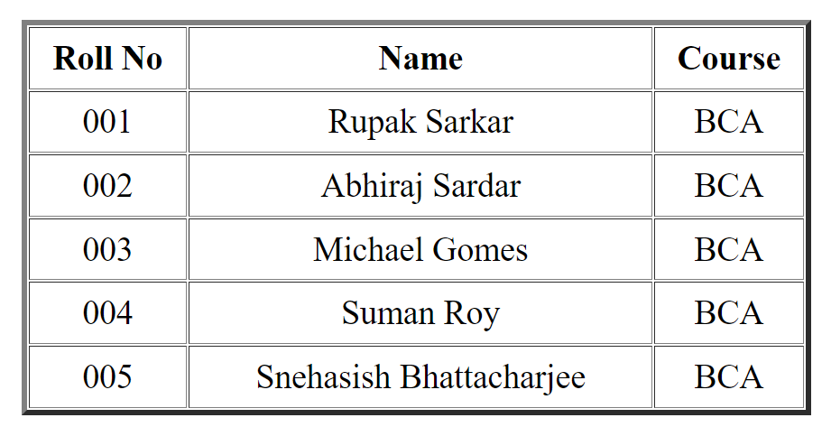

**Q.2. Create a Nested List in HTML.**

<!doctype html>

<html>

<head>

<title>Nested List</title>

<body style="font-size:20px;">

<li>Nested List Example</li>

<li>Chicken</li>

<ol>

<li>Curry</li>

<li>Kasha</li>

</ol>

<li>Beef</li>

<ol>

<li>Stew</li>

<li>Pizza</li>

</ol>

<li>Mutton</li>

<li>Fish</li>

</body>

</html>

Example:

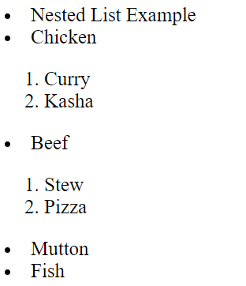

**Q.3. Create a Table in HTML using Pre tag.**

<!doctype html>

<head>

<title>Table Using pre tag</title>

<body>

<pre>

<h2 style="margin:auto;margin-left:"> Name &nbsp&nbspCourse Gmail </h2>

<h2> Rupak &nbsp&nbspBCA rupak_s.bca@msit </h2>

<h2> Michael BCA micheael_g.bca@msit </h2>

<h2> Abhiraj BCA abhiraj_s.bca@msit </h2>

<h2> Suman &nbsp&nbspBCA suman_r.bca@msit </h2>

</pre>

</body>

</html>

Example:

